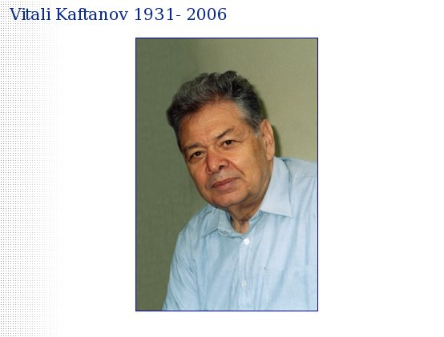

Vitali Kaftanov who died on 14 September 2006, at the age of 74 years old, was an outstanding Russian physicist, professor, and former deputy director of Theoretical and Experimental Physics (ITEP) in Moscow. He was born on 3 December 1931 in Moscow into the family of a well-known soviet scientist Sergey Kaftanov. In 1954 he graduated with honours from Moscow State University department of physics, he where specialised in nuclear physics.
In the mid-1950s international contacts between Soviet scientists and their foreign colleagues started to develop. The young physicist Vitali Kaftanov, fluent in English, was included in a Soviet government delegation, which participated in international conferences on the peaceful use of atomic energy taking place in Geneva under the auspices of UN. It was at this meeting that he met colleagues from the recently founded CERN. He began as a scientific researcher at ITEP, where he worked on similar issues to his CERN colleagues. In 1960 the Directorate of CERN made a proposal to the Soviet Academy of Sciences that Soviet scientists could participate in international experiments. The first candidate for this role was Vitali Kaftanov. Since that time Vitali Kaftanov was closely related to CERN and spent the major part of his life in Geneva. He was actively involved in the development of scientific technology and cultural collaboration between Russia and Switzerland. For a long period of time he was the head of the neutrino-research programme of the Moscow-ITEP institute, which led to CERN, IHEP (Protvino) and Fermilab accelerators.
In the last 15 years, Vitali Kaftanov was a member of the CMS project. He was one of the founders of CMS Russia and the Dubna member-states (RDMS) collaboration. He was particularly involved in CMS magnet design and construction as a founding member of the magnet technical board. For a long time Vitali Kaftanov was the RDMS technical coordinator and played a key role in the assembly and commissioning of the CMS detector.
His collaborative attitude and devotion to his work won him high regard and the admiration of all who know him. He will be sorely missed.
His colleagues and friends from the CMS collaboration

Copyright CERN

